KENDRIYA VIDYALAYA TAMENGLONG

Summative Assessment II (2015-16)

Subject: E V S Time: 02 Hours

Class: IV Date:

Name : ................................. Roll no…………

|  |  |  |  |  |
| --- | --- | --- | --- | --- |
| COMPETENCY | OBSERVATION(20) | IDENTIFICATION(20) | DISOVERY OF FACTS(20) | TOTAL(60) |
| VALUE POINTS |  |  |  |  |
| GRADE |  |  |  |  |

Sign of invigilator sign of evaluator.

OBSERVATION AND REPORTING

1. **Observe the pictures and answer the following** :

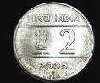

In which country can you use this coin ?

______________________

Which people use this.

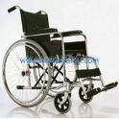 _______________________

The bird makes beautiful nests for its partner.

_____________________

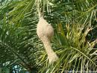

A common desert tree which looks like the coconut

tree .

__________________________

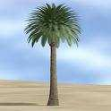

The dress worn by the assame woman:

_______________________

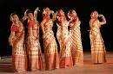

II. **Answer the following**:

1. Why was Shanta not tired ?

___________________________________________________________________________________________________________________________________________________________________________________________________________________________

2.What does Wahida do as a medical officer on the ship ?

_________________________________________________________________________

__________________________________________________________________________________________________________________________________________________

3.How did Pochampalli cloth get its name ?

________________________________________________________________________

________________________________________________________________________

4. Why do people cover their heads in Abu Dhabi ?

___________________________________________________________________________________________________________________________________________________________________________________________________________________________

5. What do you understand by these words:-

a) Prism _____________________________________________________

b) Sand dunes ___________________________________________

iii) Match the following according to the places where the birds make their nest:

1. Dove in or around our house
2. Indian Robin old building
3. Crow courtyard, thorns, mehendi hedge
4. Sparrow between the stones
5. Pigeon high up on a tree

INDENTIFICATION & CLASSIFICATION

Identify the thing and write its use.

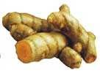

**____________________________________________________**



What is the use of this vessel ?

**_______________________________________**

 To which country does this belong to ?

**____________________________________________________**

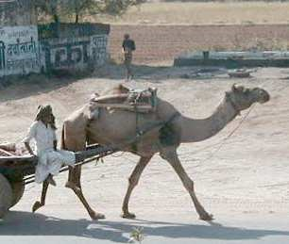

The person who used it

uu uuses it.

___________________________________________

Name the state where this is used uused.

_______________________________________

II. **Answer the following** :

1. Why should the weeds be removed ?

____________________________________________________________________

____________________________________________________________________

2. Why did Nandita come to Mumbai ?

_________________________________________________________________________

________________________________________________________________________

1. What should we do if we have diarrohea and vomiting ?

____________________________________________________________________________________________________________________________________________________________________________________________________________________________________________________________________________________________

1. What do you know about –

Bihu _____________________________________________________________

Uruka ___________________________________________________________

1. What did Phali, Nazu and her friends do on the beach ?

____________________________________________________________________________________________________________________________________________________________________________________________________________________

1. Draw a picture of different food items:

DISCOVERY OF FACTS

1. Match the following:
2. A person who cannot speak blind
3. A person who cannot hear lame
4. A person who cannot walk deaf
5. A person who cannot see dumb
6. Write the few sentences about the desert oak ?

__________________________________________________________________________________________________________________________________________________________________________________________________________________________________________________________________________________________________________________________________________________________________

1. Why do birds make nests ?

____________________________________________________________________________________________________________________________________________________________________________________________________________________

1. Write any five uses of water ?

___________________________________________________________________________________________________________________________________________________________________________________________________________________________________________________________________________________________________________________________________________________________________

1. How do the weavers decide the size of the needles ?

_____________________________________________________________________________________________________________________________________________________________________________________________________________________

1. 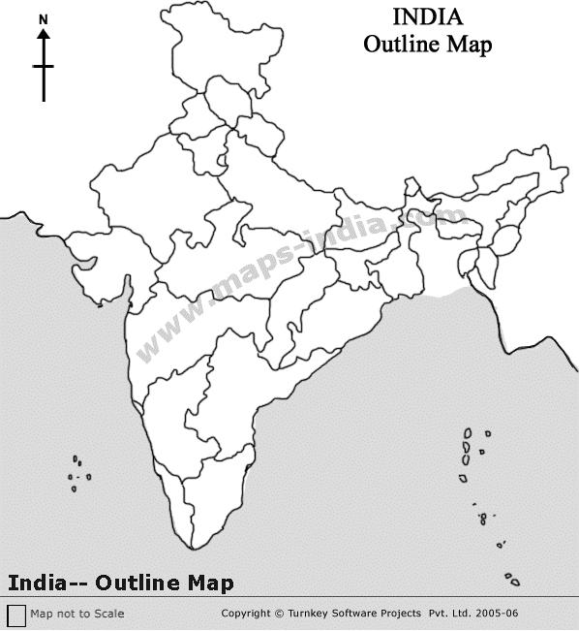Identify the following states on the map.
2. Jammu and Kashmir
3. Kerala
4. Assam
5. Maharashtra
6. karnataka